关于公开征求金普新区6个乡镇级集中式饮用水水源保护区区划方案意见的通知

为了进一步规范化水源地管理，根据大连市生态环境局总体工作要求，我局对登沙河街道程家村、华家街道华家村、向应街道关家村、杏树街道柳家村、炮台街道磙桥村、三十里堡街道红果社区等6个乡镇级集中式饮用水水源地开展了水源保护区划定工作，并形成了区划方案。现就以上方案向社会公开征求意见，征求意见截止日期为2021年9月7日。公众可通过以下途径和方式提出意见建议（提出意见或建议请留下真实姓名和联系方式，以便进一步沟通联系）。

附件：6处地下水型水源地饮用水水源保护区区划方案

大连市金普新区（金州）生态环境分局

2021年8月31日

联系人：姜亚楠 联系电话： 88037917

电子邮箱： hb87619307@163.com

通信地址：大连经济技术开发区金马路9号行政办公区金普新区生态环境分局 邮编： 116600

附件：

6处地下水型水源地饮用水水源保护区区划方案

| **序号** | **水源名称** | **水源类型** | **取水口坐标** | | **保护区区划方案** | | **保护区面积** | **保护区周长** |
| --- | --- | --- | --- | --- | --- | --- | --- | --- |
| **X** | **Y** | **级别** | **陆域** | **（平方米）** | **（米）** |
| 1 | 登沙河街道程家村地下水型水源地 | 1眼地下水井 | 4346119.848 | 41419825.83 | 一级 | 以方塘西北角A01为起点，顺时针沿方塘北侧小路至房屋围墙角A08，向南沿围墙至A09，向西沿以取水井外扩30米方向至A10，向西北方向沿小路至方塘西南方向沟渠处A13，向北沿沟渠至A01止。 | 21420.61 | 646.04 |
| 2 | 华家街道华家村地下水型水源地 | 1眼地下水井 | 4350676.859 | 41413969.73 | 一级 | 以方塘西北角沟渠口A01为起点，顺时针沿沟渠方向至路口相交处A04，向南沿方塘东侧小路至方塘东南角A06，向西沿方塘南侧栅栏至河流防洪墙A07，向北沿防洪墙方向至A01止 | 97426.35 | 1284.32 |
| 3 | 向应街道关家村地下水型水源地 | 1眼地下水井 | 4350071.659 | 41408580.46 | 一级 | 以取水井外扩30米后方塘西北角A01为起点，顺时针沿方塘北侧栅栏外3.5米小路至A04，向南沿方塘东侧小路至A07，向西沿方塘南侧栅栏外5米延伸至A08，向西北方向至取水井外扩30米的A09，向北沿小路至A01止 | 17378.25 | 559.8 |
| 4 | 杏树街道柳家村地下水型水源地 | 1眼地下水井 | 4347463.815 | 41424072.43 | 一级 | 以方塘西北侧房屋西侧围墙角A01为起点，顺时针沿围墙至西北角A02，向东沿围墙至围墙与小路相交处A03，向北至小路道口A04，向东沿道边至路口处A05，向南沿路边至围墙处A06，沿围墙至方塘东北角A08，向南沿围墙至方塘东南角A09，向西至方塘西南角A10，向北沿围墙至方塘西侧房屋围墙东南角A11，沿围墙至A01止。 | 27719.48 | 749.11 |
| 5 | 炮台街道磙桥村地下水型水源地 | 1处平塘 | 4373342.63 | 41390268.7 | 一级 | 以北侧方塘靠路边西侧角A01为起点，顺时针沿道边至A03，向东沿道边至A06，向北沿道边至与路口相交点A08，向东沿北侧方塘东边栅栏至A10、A17、A29，向南沿北侧方塘东边栅栏至南侧方塘东北角路口A34，向南沿南侧方塘东侧路边至A40，沿距南侧方塘南侧30米方向与距西侧30米方向至路边A43，向北沿路边至A01止 | 110758.22 | 2048.22 |
| 6 | 三十里堡街道红果社区地下水型水源地 | 1眼地下水井 | 4347703.548 | 41395495.38 | 一级 | 以水源地取水口为中心，半径30米范围之内的圆 | 3053.55 | 195.89 |

**登沙河街道程家村饮用水水源保护区界址点坐标表**

|  |  |  |  |  |
| --- | --- | --- | --- | --- |
| 编号 | 2000国家大地坐标系  X坐标 | 2000国家大地坐标系  Y坐标 | 纬度 | 经度 |
| A01 | 4346208.9499 | 41419657.5056 | 39°14′45.0086" | 122°04′09.5500" |
| A02 | 4346207.4259 | 41419664.6176 | 39°14′44.9615" | 122°04′09.8473" |
| A03 | 4346193.5829 | 41419702.2096 | 39°14′44.5252" | 122°04′11.4207" |
| A04 | 4346182.9149 | 41419730.4037 | 39°14′44.1887" | 122°04′12.6008" |
| A05 | 4346172.1199 | 41419755.8037 | 39°14′43.8472" | 122°04′13.6645" |
| A06 | 4346160.3088 | 41419786.2838 | 39°14′43.4744" | 122°04′14.9405" |
| A07 | 4346156.2024 | 41419794.3973 | 39°14′43.3439" | 122°04′15.2806" |
| A08 | 4346117.7848 | 41419885.3083 | 39°14′42.1286" | 122°04′19.0877" |
| A09 | 4346077.6324 | 41419852.2223 | 39°14′40.8157" | 122°04′17.7253" |
| A10 | 4346079.7491 | 41419640.9785 | 39°14′40.8141" | 122°04′08.9163" |
| A11 | 4346096.4284 | 41419640.0472 | 39°14′41.3545" | 122°04′08.8703" |
| A12 | 4346107.3497 | 41419631.5975 | 39°14′41.7058" | 122°04′08.5133" |
| A13 | 4346142.1478 | 41419630.9625 | 39°14′42.8338" | 122°04′08.4719" |

登沙河街道程家村地下水型水源地饮用水水源保护区定界图

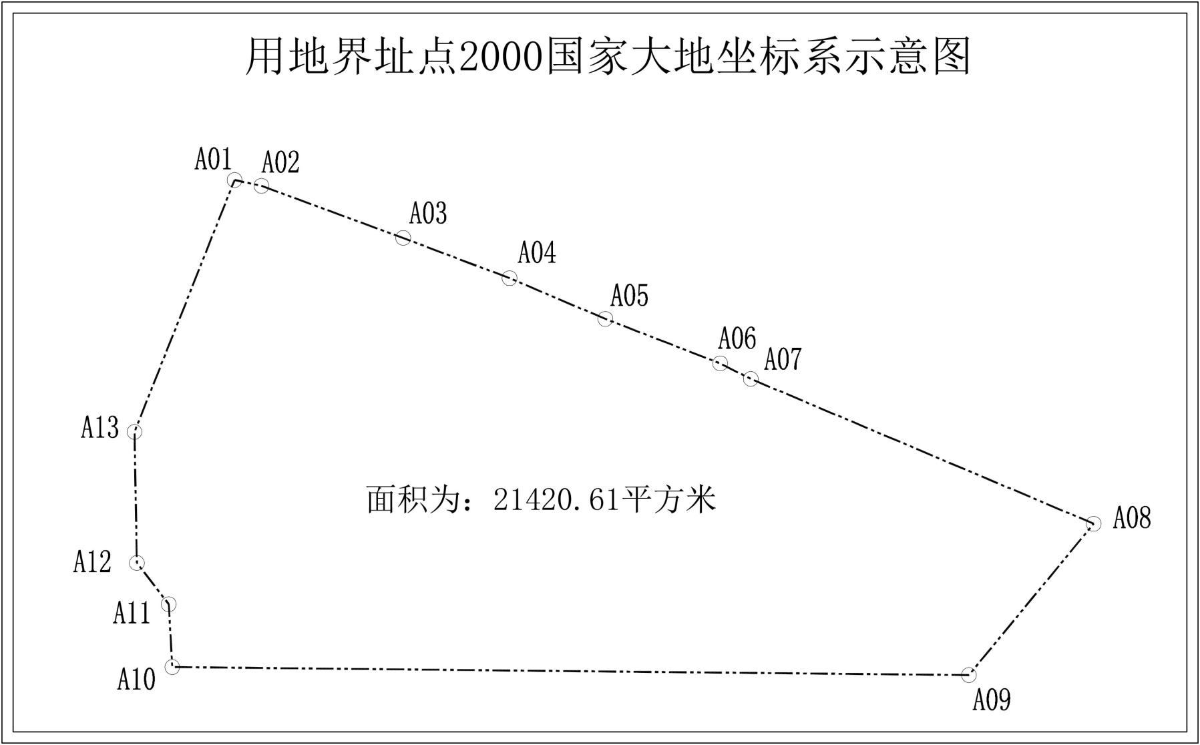

**华家街道华家村饮用水水源保护区界址点坐标表**

|  |  |  |  |  |
| --- | --- | --- | --- | --- |
| 编号 | 2000国家大地坐标系  X坐标 | 2000国家大地坐标系  Y坐标 | 纬度 | 经度 |
| A01 | 4350706.1832 | 41413719.9841 | 39°17′08.7640" | 121°59′59.9054" |
| A02 | 4350709.9685 | 41413832.1042 | 39°17′08.9269" | 122°00′04.5812" |
| A03 | 4350708.1905 | 41413881.2533 | 39°17′08.8868" | 122°00′06.6326" |
| A04 | 4350693.2045 | 41414015.1539 | 39°17′08.4488" | 122°00′12.2257" |
| A05 | 4350565.7770 | 41413979.2795 | 39°17′04.3046" | 122°00′10.7877" |
| A06 | 4350316.6347 | 41413933.8571 | 39°16′56.2108" | 122°00′09.0073" |
| A07 | 4350315.1583 | 41413722.3081 | 39°16′56.0872" | 122°00′00.1826" |

华家街道华家村地下水型水源地饮用水水源保护区定界图

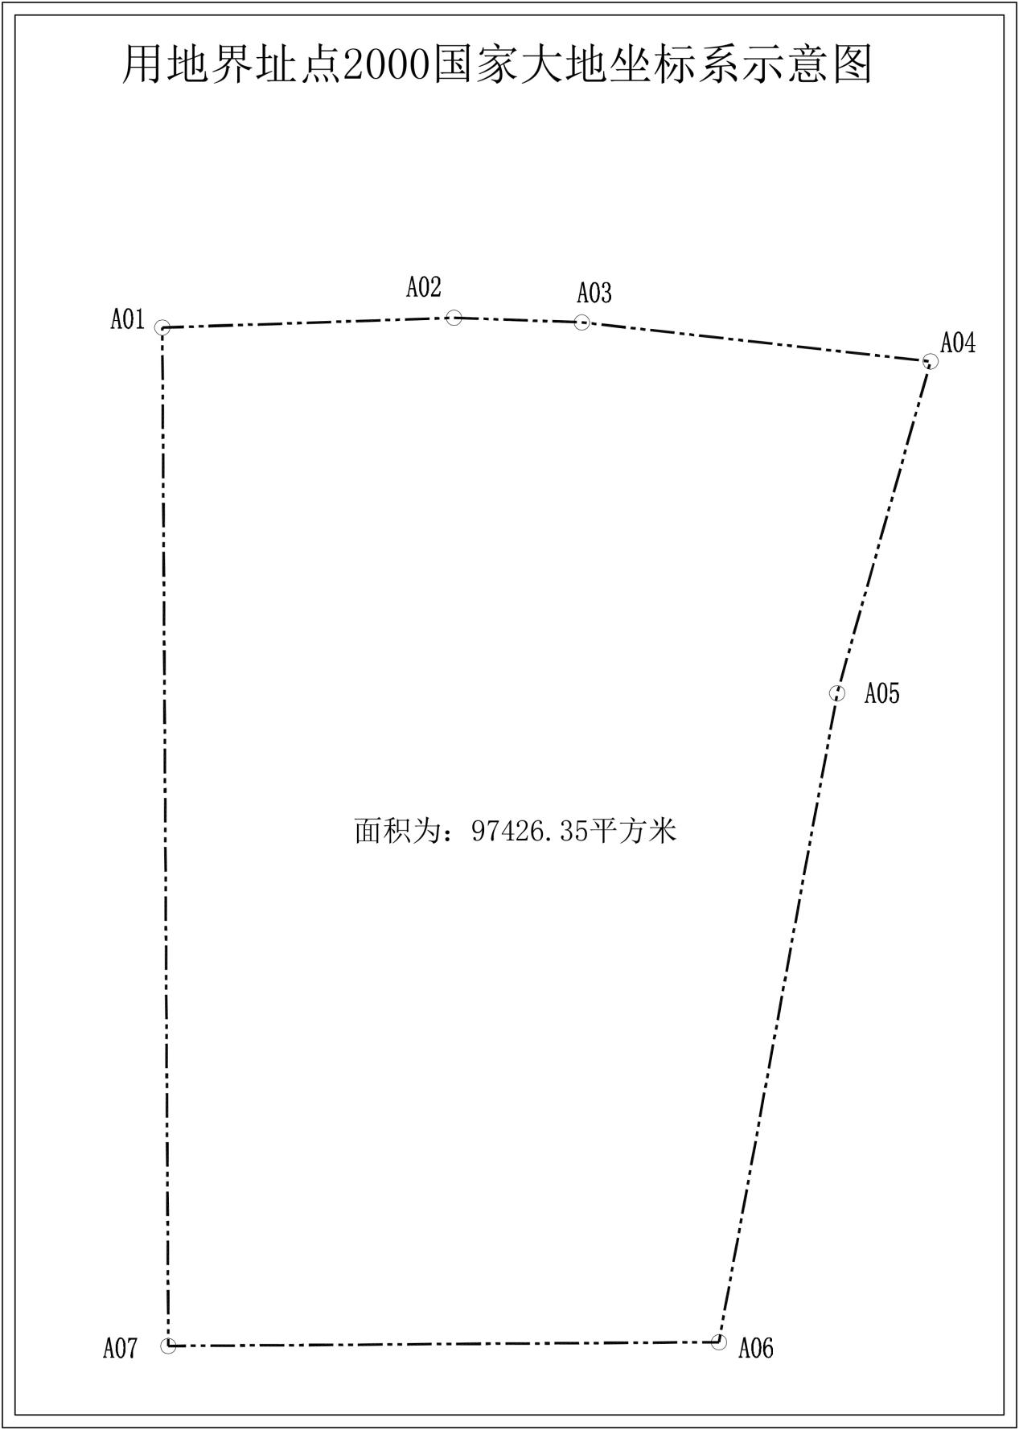

**向应街道关家村饮用水水源保护区界址点坐标表**

|  |  |  |  |  |
| --- | --- | --- | --- | --- |
| 编号 | 2000国家大地坐标系  X坐标 | 2000国家大地坐标系  Y坐标 | 纬度 | 经度 |
| A01 | 4350129.7061 | 41408573.8085 | 39°16′48.1751″ | 121°56′25.4926″ |
| A02 | 4350118.9391 | 41408594.2869 | 39°16′47.8338″ | 121°56′26.3521″ |
| A03 | 4350108.1441 | 41408603.3886 | 39°16′47.4873″ | 121°56′26.7370″ |
| A04 | 4350030.4623 | 41408747.1106 | 39°16′45.0232″ | 121°56′32.7704″ |
| A05 | 4349984.7422 | 41408721.2872 | 39°16′43.5312″ | 121°56′31.7154″ |
| A06 | 4349975.6405 | 41408706.4705 | 39°16′43.2305″ | 121°56′31.1018″ |
| A07 | 4349960.1888 | 41408693.3471 | 39°16′42.7245″ | 121°56′30.5619″ |
| A08 | 4350026.6522 | 41408563.3835 | 39°16′44.8300″ | 121°56′25.1080″ |
| A09 | 4350064.2546 | 41408535.1626 | 39°16′46.0384″ | 121°56′23.9124″ |

向应街道华家村地下水型水源地饮用水水源保护区定界图

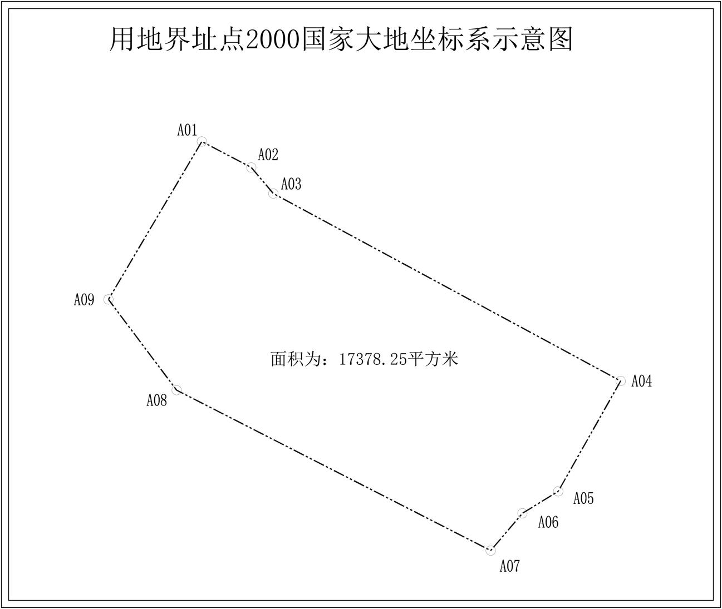

**杏树街道柳家村饮用水水源保护区界址点坐标表**

|  |  |  |  |  |
| --- | --- | --- | --- | --- |
| 编号 | 2000国家大地坐标系  X坐标 | 2000国家大地坐标系  Y坐标 | 纬度 | 经度 |
| A01 | 4347541.4643 | 41423979.5495 | 39°15′29.6137" | 122°07′09.2274" |
| A02 | 4347562.7837 | 41424001.7052 | 39°15′30.3119" | 122°07′10.1427" |
| A03 | 4347544.1709 | 41424020.3282 | 39°15′29.7143" | 122°07′10.9269" |
| A04 | 4347556.9312 | 41424034.0470 | 39°15′30.1323" | 122°07′11.4939" |
| A05 | 4347467.3484 | 41424123.4248 | 39°15′27.2560" | 122°07′15.2577" |
| A06 | 4347454.8950 | 41424109.8281 | 39°15′26.8479" | 122°07′14.6957" |
| A07 | 4347428.9150 | 41424134.9699 | 39°15′26.0135" | 122°07′15.7547" |
| A08 | 4347398.8498 | 41424146.6582 | 39°15′25.0424" | 122°07′16.2543" |
| A09 | 4347307.5874 | 41424054.7904 | 39°15′22.0545" | 122°07′12.4601" |
| A10 | 4347430.0435 | 41423935.8430 | 39°15′25.9873" | 122°07′07.4498" |
| A11 | 4347506.3276 | 41424014.8980 | 39°15′28.4856" | 122°07′10.7158" |

杏树街道柳家村地下水型水源地饮用水水源保护区定界图

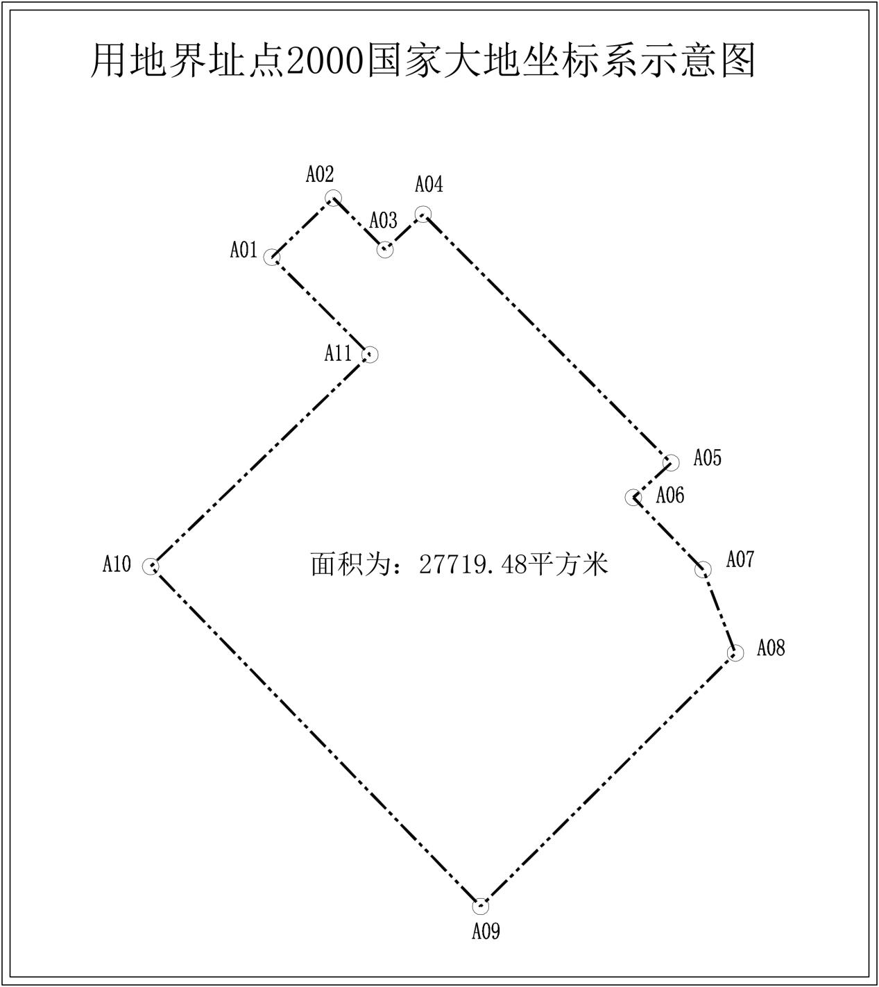

**炮台街道磙桥村饮用水水源保护区界址点坐标表**

| 编号 | 2000国家大地坐标系  X坐标 | 2000国家大地坐标系  Y坐标 | 纬度 | 经度 |
| --- | --- | --- | --- | --- |
| A01 | 4373679.2146 | 41389974.0796 | 39°29′23.8169" | 121°43′15.7194" |
| A02 | 4373684.1788 | 41389978.0243 | 39°29′23.9796" | 121°43′15.8815" |
| A03 | 4373732.9172 | 41390052.7829 | 39°29′25.5940" | 121°43′18.9803" |
| A04 | 4373735.5630 | 41390072.8913 | 39°29′25.6890" | 121°43′19.8200" |
| A05 | 4373728.4192 | 41390102.2601 | 39°29′25.4709" | 121°43′21.0530" |
| A06 | 4373725.5794 | 41390175.3382 | 39°29′25.4124" | 121°43′24.1121" |
| A07 | 4373733.1994 | 41390186.3449 | 39°29′25.6645" | 121°43′24.5681" |
| A08 | 4373904.4866 | 41390200.2972 | 39°29′31.2236" | 121°43′25.0502" |
| A09 | 4373901.6505 | 41390219.7165 | 39°29′31.1405" | 121°43′25.8644" |
| A10 | 4373811.1132 | 41390217.0348 | 39°29′28.2043" | 121°43′25.8059" |
| A11 | 4373808.0194 | 41390217.7188 | 39°29′28.1044" | 121°43′25.8363" |
| A12 | 4373807.1163 | 41390222.6531 | 39°29′28.0774" | 121°43′26.0433" |
| A13 | 4373804.8755 | 41390234.8951 | 39°29′28.0103" | 121°43′26.5568" |
| A14 | 4373801.6731 | 41390252.3904 | 39°29′27.9146" | 121°43′27.2907" |
| A15 | 4373798.9317 | 41390267.3674 | 39°29′27.8326" | 121°43′27.9189" |
| A16 | 4373797.8395 | 41390269.3613 | 39°29′27.7981" | 121°43′28.0030" |
| A17 | 4373796.7179 | 41390271.4088 | 39°29′27.7627" | 121°43′28.0893" |
| A18 | 4373794.6022 | 41390272.5220 | 39°29′27.6946" | 121°43′28.1371" |
| A19 | 4373792.7684 | 41390273.4868 | 39°29′27.6356" | 121°43′28.1786" |
| A20 | 4373780.9438 | 41390273.8005 | 39°29′27.2524" | 121°43′28.1987" |
| A21 | 4373743.2417 | 41390274.8006 | 39°29′26.0307" | 121°43′28.2629" |
| A22 | 4373713.3767 | 41390275.1742 | 39°29′25.0627" | 121°43′28.2962" |
| A23 | 4373676.7930 | 41390275.6318 | 39°29′23.8770" | 121°43′28.3370" |
| A24 | 4373674.3425 | 41390276.4088 | 39°29′23.7979" | 121°43′28.3710" |
| A25 | 4373671.7198 | 41390277.2405 | 39°29′23.7133" | 121°43′28.4073" |
| A26 | 4373668.9745 | 41390278.1110 | 39°29′23.6247" | 121°43′28.4454" |
| A27 | 4373665.7070 | 41390280.3502 | 39°29′23.5198" | 121°43′28.5410" |
| A28 | 4373650.6834 | 41390288.6286 | 39°29′23.0365" | 121°43′28.8963" |
| A29 | 4373627.1891 | 41390293.0546 | 39°29′22.2770" | 121°43′29.0953" |
| A30 | 4373556.9549 | 41390289.6041 | 39°29′19.9986" | 121°43′28.9926" |
| A31 | 4373494.0483 | 41390284.4015 | 39°29′17.9569" | 121°43′28.8122" |
| A32 | 4373392.8777 | 41390274.2920 | 39°29′14.6726" | 121°43′28.4492" |
| A33 | 4373383.0518 | 41390275.4602 | 39°29′14.3547" | 121°43′28.5039" |
| A34 | 4373361.8323 | 41390273.3314 | 39°29′13.6658" | 121°43′28.4274" |
| A35 | 4373357.3344 | 41390277.5647 | 39°29′13.5219" | 121°43′28.6071" |
| A36 | 4373348.0740 | 41390281.5335 | 39°29′13.2236" | 121°43′28.7787" |
| A37 | 4373292.5114 | 41390271.4793 | 39°29′11.4178" | 121°43′28.3909" |
| A38 | 4373193.8216 | 41390255.0751 | 39°29′08.2110" | 121°43′27.7631" |
| A39 | 4373155.9861 | 41390247.1376 | 39°29′06.9808" | 121°43′27.4535" |
| A40 | 4373139.5819 | 41390242.6397 | 39°29′06.4470" | 121°43′27.2750" |
| A41 | 4373141.7989 | 41390229.3602 | 39°29′06.5128" | 121°43′26.7182" |
| A42 | 4373175.4897 | 41390074.1269 | 39°29′07.5336" | 121°43′20.2041" |
| A43 | 4373364.6102 | 41390112.9891 | 39°29′13.6822" | 121°43′21.7177" |
| A44 | 4373368.1839 | 41390121.0401 | 39°29′13.8018" | 121°43′22.0524" |
| A45 | 4373372.9840 | 41390135.6346 | 39°29′13.9641" | 121°43′22.6601" |
| A46 | 4373377.5256 | 41390163.1545 | 39°29′14.1239" | 121°43′23.8087" |
| A47 | 4373392.6828 | 41390166.9687 | 39°29′14.6170" | 121°43′23.9593" |
| A48 | 4373453.7301 | 41390164.2576 | 39°29′16.5948" | 121°43′23.8097" |
| A49 | 4373567.0610 | 41390125.0655 | 39°29′20.2506" | 121°43′22.1028" |
| A50 | 4373609.1828 | 41390086.9654 | 39°29′21.5986" | 121°43′20.4838" |
| A51 | 4373631.6195 | 41390044.2086 | 39°29′22.3062" | 121°43′18.6817" |
| A52 | 4373647.9178 | 41390003.3569 | 39°29′22.8158" | 121°43′16.9629" |
| A53 | 4373662.0995 | 41389984.3068 | 39°29′23.2668" | 121°43′16.1575" |

炮台街道磙桥村地下水型水源地饮用水水源保护区定界图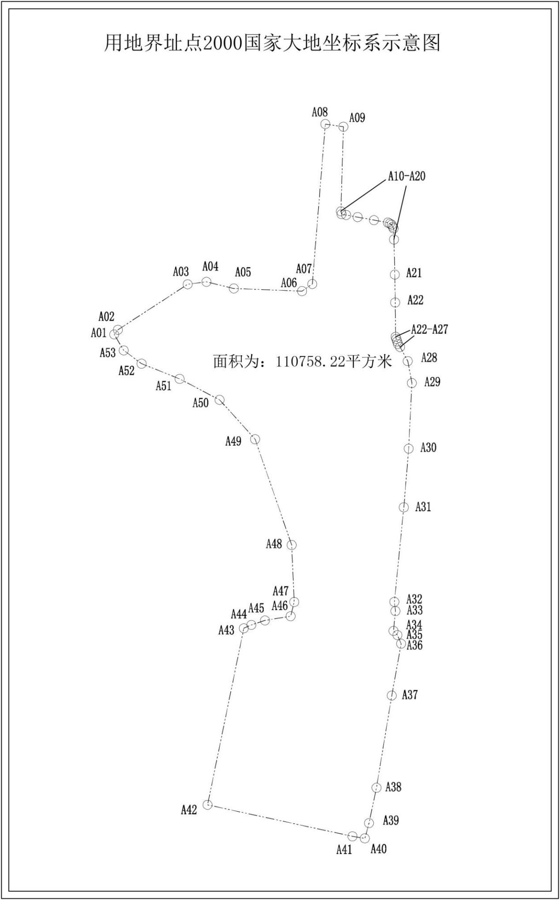

三十里堡街道红果社区地下水型水源地饮用水水源保护区定界图

